# BIT WEB3 APPLICATION FOR STUDENT RECORD MANAGEMENT

## Introduction

**BIT Web3 Application** is a powerful software application developed by Beyond Imagination Technologies to empower the educational institutes by automating and streamlining most of the institute’s activities. The application takes care of all institutional activities, from enrolling students to long term transcript verification including routine activities like attendance, assignments and examination etc.

**BIT application** derives its strength from its underlying web3 architecture. It uses Blockchain technology for data storage and verification; which makes it incredibly powerful, secure and tamper proof. **BIT application** is a giant leap in the digitization process of our educational institutes.

## How It works

**BIT application** uses blockchain technology for data storage and verification. All student and institutional data are added to the blockchain in the form of transactions.

The blockchain technology is an immutable, distributed ledger of transactions. This means that the data stored on the blockchain can never be lost, deleted or tampered with. This is the safest form of record keeping. The data persists on the network for years and years to come.

Some of the features/benefits of blockchain technology are:

1. It is a distributed ledger of transactions which means there is no single point of failure.
2. Immutability of the ledger ensures that the data persists for years and years to come.
3. There are no down times as the network is spread over thousands of nodes.
4. The blockchain network is immune to hardware malfunctions.
5. The blockchain network persists over a closed network, which makes it secure from foreign influence, viruses and hackers.

**BIT application** also allows the storage of large files like certificates, grade-cards, photos, videos etc. by using a decentralized file storage system known as IPFS. IPFS is a peer-to-peer hypermedia protocol that divides a file into thousands of small unreadable chunks of data and distributes it over peer nodes across the globe. It generates a unique hash value for every file, which is stored on the blockchain. It makes the data storage many times more efficient, safe and faster.

**BIT application** comes with a set of attractive and simple user interfaces. This makes the application extremely easy to use by people of all age groups. The interface is prepared in a way that the users can interact with all the features of the application right form day 1, without any prior training.

The workflow of **BIT application** can be summarized by the following diagram.

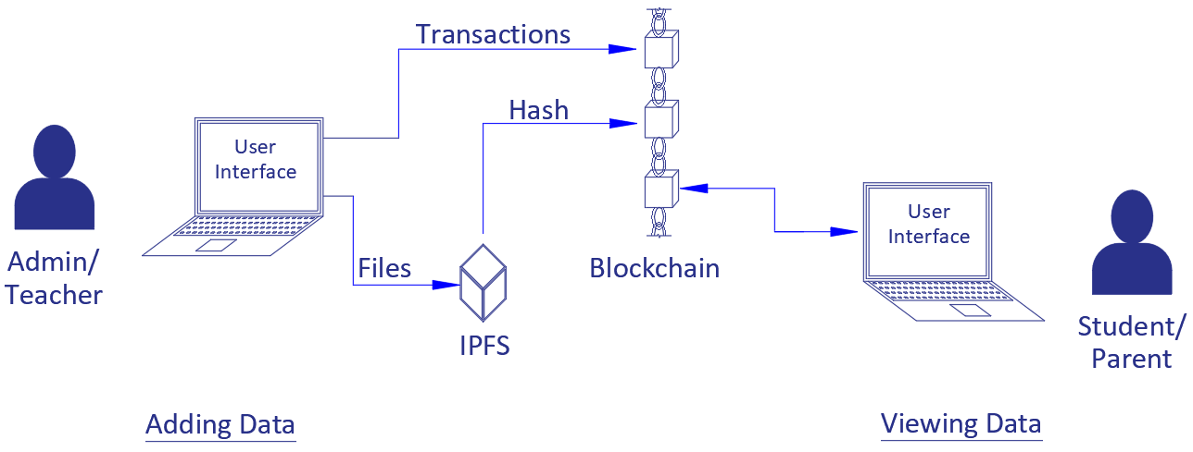

*Fig. 1.2.1 Application work flow.*

## Features

**BIT application** has all the important functionality of an educational institute along with some advanced yet much needed features.

1. Student Record Management
2. Student Credentials Management
3. Student Attendance Management
4. Student Assignment Management
5. Student Academic Performance Management
6. Record keeping of Faculty feedbacks
7. Dashboard for each Student
8. School Dashboard
9. Record of student nonacademic activities

## Advantages over existing Web2.0 applications

The underlying web3.0 architecture of **BIT application** makes it considerably superior to existing application with web 2.0 architecture. The main advantages are as follows:

|  |  |  |
| --- | --- | --- |
| S. No | BIT Web3.0 application | Existing Web2.0 applications |
| 1 | Data is stored on a distributed ledger. | Data is stored on a centralized server. |
| 2 | There is no single point of failure due its decentralized nature. | The client-server model of existing applications has a single point of failure. |
| 3 | The distributed ledger (blockchain technology) makes the data immutable and tamper proof. | The data is very much mutable and can easily be tampered with. Data once deleted is lost forever. |
| 4 | The application relies on a network of thousands of nodes spread across the globe; which makes it impervious to hardware malfunctions. | These applications are prone to down times and hardware malfunctions. |
| 5 | The data exists over a closed network and verified with consensus algorithms. This makes the network secure from foreign influences, virus and hackers. | These applications are vulnerable to virus and hackers. Most of these applications have been known to be attacked and hacked in the past. |